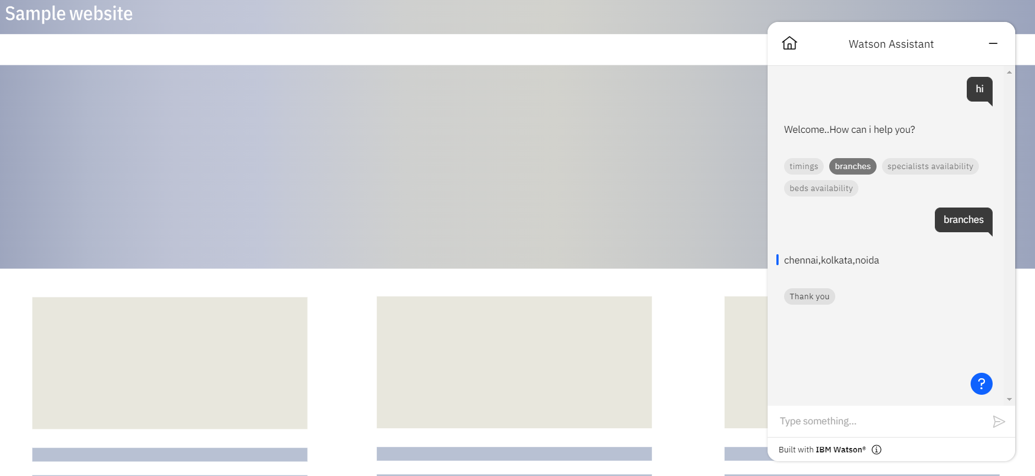

https://web-chat.global.assistant.watson.appdomain.cloud/preview.html?backgroundImageURL=https%3A%2F%2Fau-syd.assistant.watson.cloud.ibm.com%2Fpublic%2Fimages%2Fupx-ca45043e-7da9-441a-aae8-ed5538399ced%3A%3Af1930561-1262-4b5e-94b0-e9d373caa680&integrationID=34825471-f714-432f-b576-23627a7ac917&region=au-syd&serviceInstanceID=ca45043e-7da9-441a-aae8-ed5538399ced